ALGORITHMS

Algorithm for template matching :

**Template Matching Algorithm (General)**

1. **Input**:
   * **Image**: The larger image where you want to search for the template.
   * **Template**: The smaller image that is to be matched against the larger image.
   * **Method**: The type of template matching method used (6 different methods in this case).
2. **Steps**:
   * Load the image and the template.
   * Perform template matching using different methods from OpenCV.
   * For each method, calculate the similarity (e.g., using a matching score).
   * Find the best match location.
   * Draw a rectangle around the matched region.
   * Optionally, show and save the result.
3. **Methods of Template Matching in OpenCV**: OpenCV offers the following methods for template matching:
   * cv2.TM_CCOEFF: Correlation coefficient matching.
   * cv2.TM_CCOEFF_NORMED: Normalized correlation coefficient.
   * cv2.TM_CCORR: Cross-correlation matching.
   * cv2.TM_CCORR_NORMED: Normalized cross-correlation.
   * cv2.TM_SQDIFF: Squared difference matching.
   * cv2.TM_SQDIFF_NORMED: Normalized squared difference matching.
4. **Template Matching Flow**:
   * **Step 1**: Load the image and the template.
   * **Step 2**: Loop through each of the six template matching methods.
   * **Step 3**: For each method:
     + Perform cv2.matchTemplate() with the image and template.
     + Use cv2.minMaxLoc() to get the min and max values and their corresponding locations.
     + Determine the best match based on the method.
   * **Step 4**: Draw a rectangle around the matched region using cv2.rectangle().
   * **Step 5**: Display the result using cv2.imshow() and optionally save it using cv2.imwrite().

**Output images**:

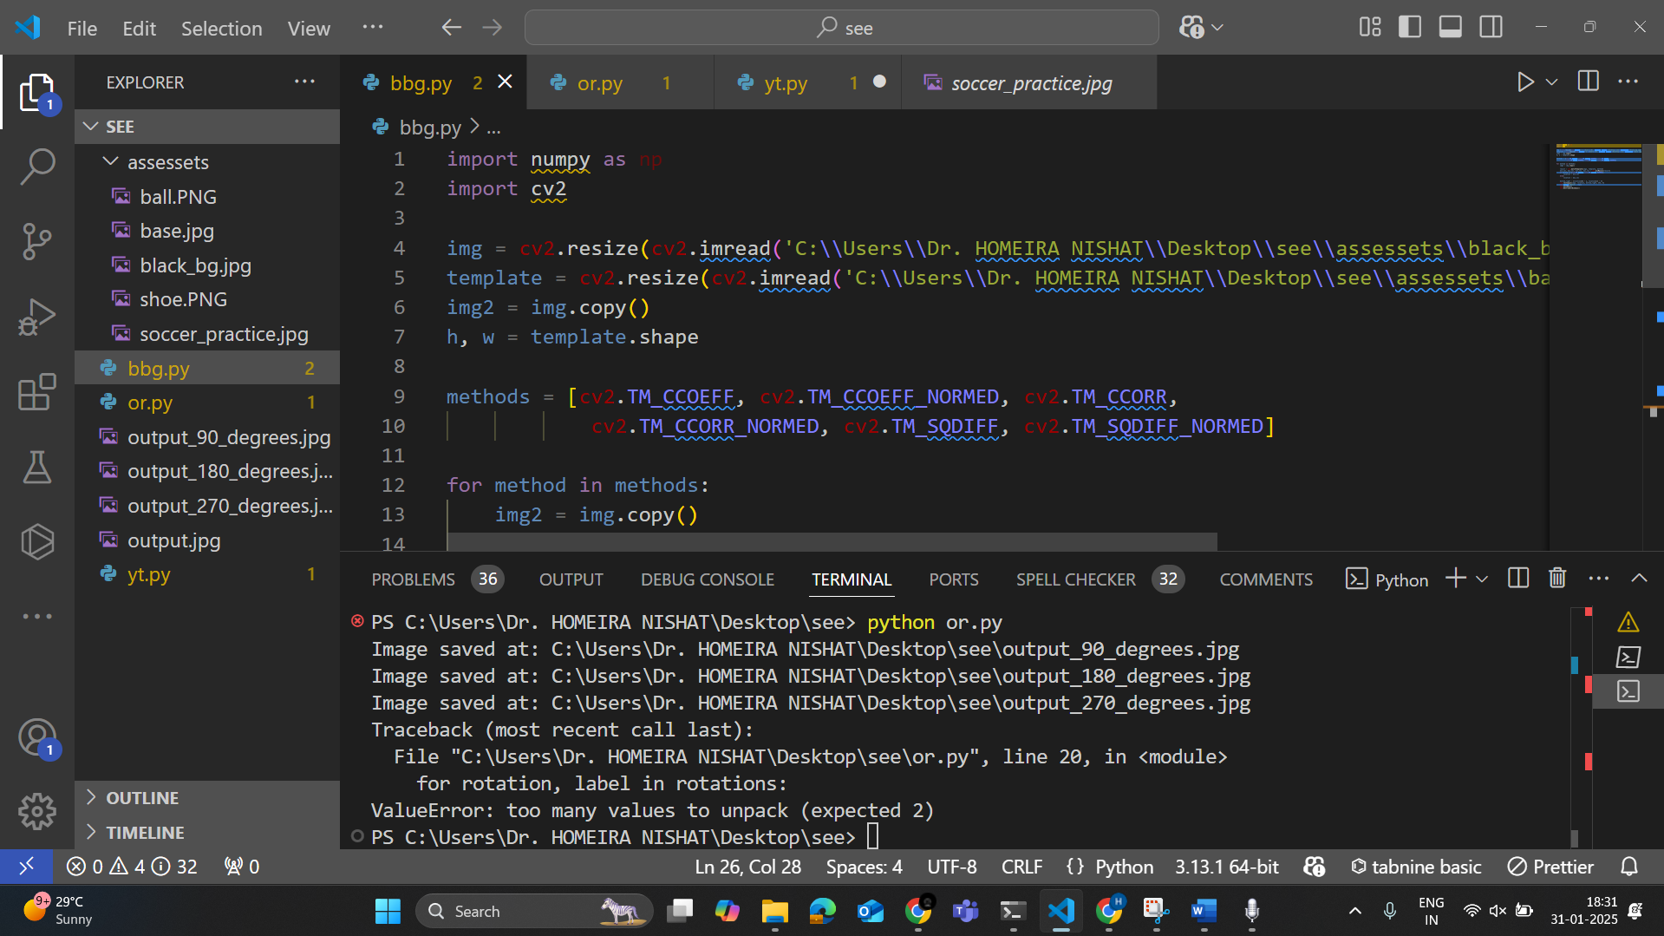



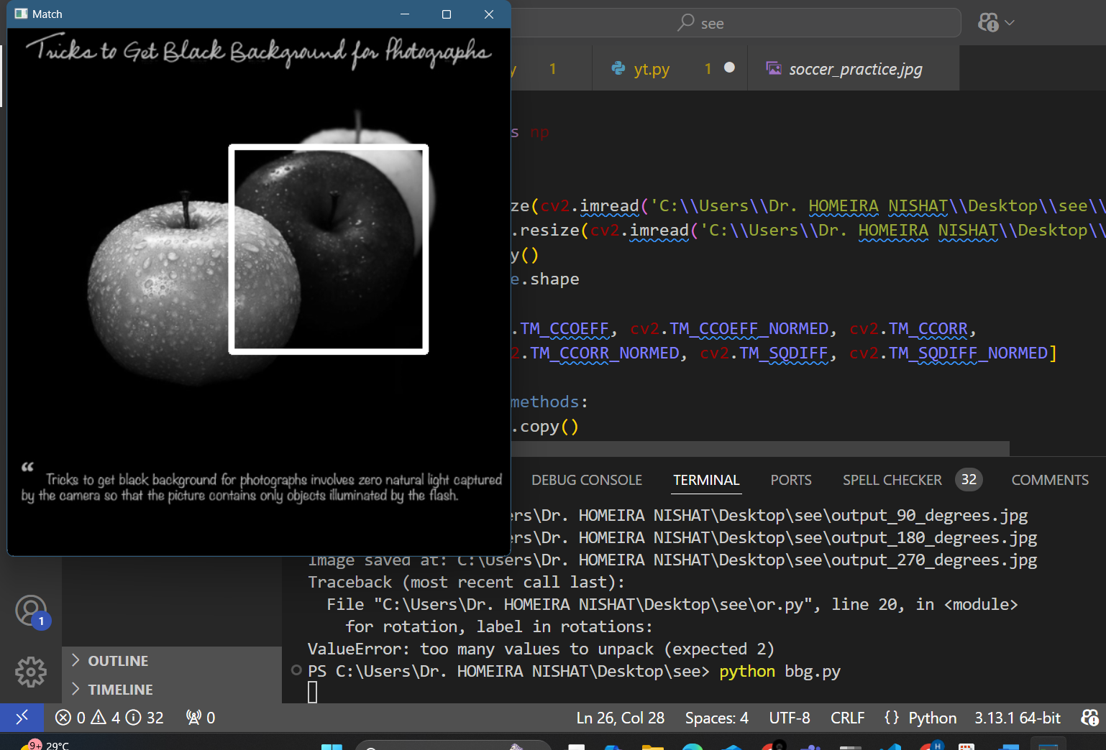



Algorithm for orientation:

**Image Rotation Algorithm (with OpenCV)**

1. **Input**:
   * **Image**: The image to be rotated.
   * **Angle**: The angle of rotation (90°, 180°, 270°, or 360°).
2. **Steps**:
   * Load the input image.
   * Apply rotation based on the specified angle:
     + For 90°: Use cv2.ROTATE_90_CLOCKWISE.
     + For 180°: Use cv2.ROTATE_180.
     + For 270°: Use cv2.ROTATE_90_COUNTERCLOCKWISE.
     + For 360°: The image remains the same.
   * Show the rotated image.
   * Save the rotated image to a file.
   * Repeat for all the rotations (90°, 180°, 270°, 360°).

**OUTPUT Images:**

